# Status of the Effort

Over the past year, we have had a strong focus on both development of theory for hybrid systems and some exciting experimental results. We have developed a method for automatic control design for hybrid systems using reachable sets. We have designed a methodology for optimal control of hybrid systems. The former has been demonstrated on the quadrotor vehicles, the latter in simulation. In addition, we have demonstrated our earlier reachable set code in real time quadrotor aerobatics. We continue to collaborate with our MURI colleagues on tool chain development, using the quadrotor as a common platform. Our next and final year of the MURI will see a continuation of the theoretical and algorithmic development for hybrid systems, and continued collaboration across the MURI locations on the quadrotor on experimental demonstrations.

**Accomplishments and New Findings**

We continued our work on developing tools, methods and other components of the project along the four objectives.

**Hybrid and Embedded Systems Theory**

**Embedded Systems Modeling and Deep Compositionality (Krogh, Tomlin, Sastry)**

As we have demonstrated throughout the course of this MURI, the control of complex nonlinear systems can be aided by modeling each system as a collection of simplified hybrid modes, each representing a particular operating regime defined by the system dynamics, or by the region of the state space in which the system operates. Guarantees on the safety and performance of such hybrid systems can still be challenging to generate, however. Reachability analysis using a dynamic game formulation provides a useful way to generate these types of guarantees: reachable sets computed using Hamilton-Jacobi methods are flexible enough to analyze a variety of systems. As a result, reachability analysis has been used on a wide range of systems. In our work this past year, we used hybrid dynamic models and reachability tools to design provably safe aerobatic maneuvers. We applied this method to the STARMAC quadrotor helicopter performing a backflip maneuver with three modes: impulse (initializing rotation), drift (motors off while rotating and free-falling), and recovery (return to controlled hover). Provably safe switching conditions on altitude, attitude, and their rates are generated using the solution of the Hamilton-Jacobi equation in the dynamic game formulation of reachable sets to guarantee that the vehicle will successfully pass through all three modes, to arrive at a specified, safe, final condition.

Figure 1: Reachable sets for the quadrotor backflip, shown in the in-plane angle phi (radians) and phi_dot (radians/s) plane. The quadrotor starts in the region labeled F (impulse mode), attains target set E, rotors switch off (D), drift mode (C), target set (B), recovery mode (A) to final hover position. 

Figure 2: Showing an experimental demonstration of the quadrotor backflip in a mosaic. (a) The quadrotor has finished the climb portion of the backflip and is starting the impulse mode. (b) The quadrotor has finished the impulse stage and is entering into the drift portion. (b)-(f) Display of the drift stage of the backflip. (f) The drift mode is concluding and the recovery has started. (f)-(j) The recovery mode is safely returning the quadrotor to its hovering position.



Figure 3: Three experimental validations (solid, dash, and dash-dot lines) of the backflip maneuver overlaid on the composite reach sets. The transitions from the impulse to drift mode are shown as black diamonds which are contained in the region E, and the transitions from the drift to the recovery mode are indicated by the black squares that are confined to region B.



### Hierarchies of Robust Hybrid and Embedded Systems (Tomlin, Krogh, Sastry)

*Reachability analysis.* We have developed a method for automatically synthesizing controllers that provide hard guarantees of safety and target reachability for sampled and quantized switched systems under bounded continuous disturbances. Techniques from hybrid system verification are used to perform continuous time differential game calculations on each sampling interval, and iterative procedures are given for computing the set of states for which there exists a feasible control sequence that satisfies the properties of safety and reachability over a finite time horizon. From this computation, we show how to obtain explicit state feedback policies in the form of multiple reachable sets, and an algorithm is given for using this feedback law in closed loop control of the system. We have applied the technique in simulation to an automated aerial refueling example, and in experiment to the quadrotor helicopter attempting to land on moving targets.

While previous methods for hybrid system reachability have found success in open loop verification of properties of hybrid systems, recovering an implementable control law that solves the reachavoid problem is in general nontrivial. In some special cases, it may be

possible to find this control law by analytic calculations or by automatic verification tools. However, there are in general no systematic methods for synthesizing explicit feedback policies that can be used in closed loop control of hybrid systems with nonlinear continuous dynamics. This is the question we seek to answer in our recent work, under the restriction that: 1) the system is switched, 2) disturbance cannot affect discrete transitions. The controller synthesis method that we have developed is based upon the game theoretic hybrid controller developed earlier, with the advantage of being able to handle disturbances, nonlinear continuous dynamics, and possibly nonconvex state constraints. We extend previous efforts by formulating an iterative procedure for computing the explicit set-valued feedback law that can be used in closed loop control of sampled and quantized switched systems, in the form of multiple reachable sets. Due to the intimate connection of game theoretic techniques to optimal control, it becomes evident that the feedback policy we synthesize is the robust minimum time to reach controller for the switched system.

Figure 4: Showing (top) the automated aerial refueling example; (bottom) the target set and reachavoid set in the relative (x-y) position and relative orientation of the UAV with respect to the tanker.

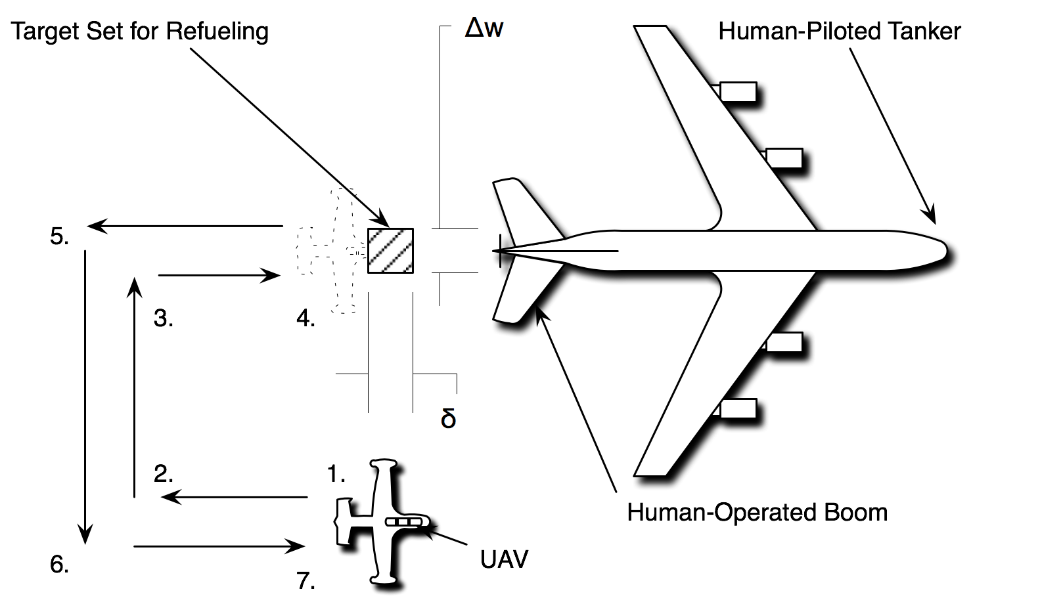

Figure 5: Experimental demonstration of new reachability calculations on STARMAC quadrotor. (a) Sets computed from which the quadrotor can reach the target set while avoiding ground and limits on velocity. (b) Experimental data shown quadrotor flying this control law.

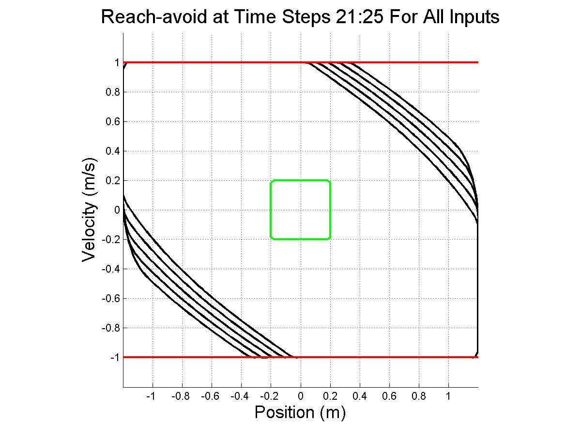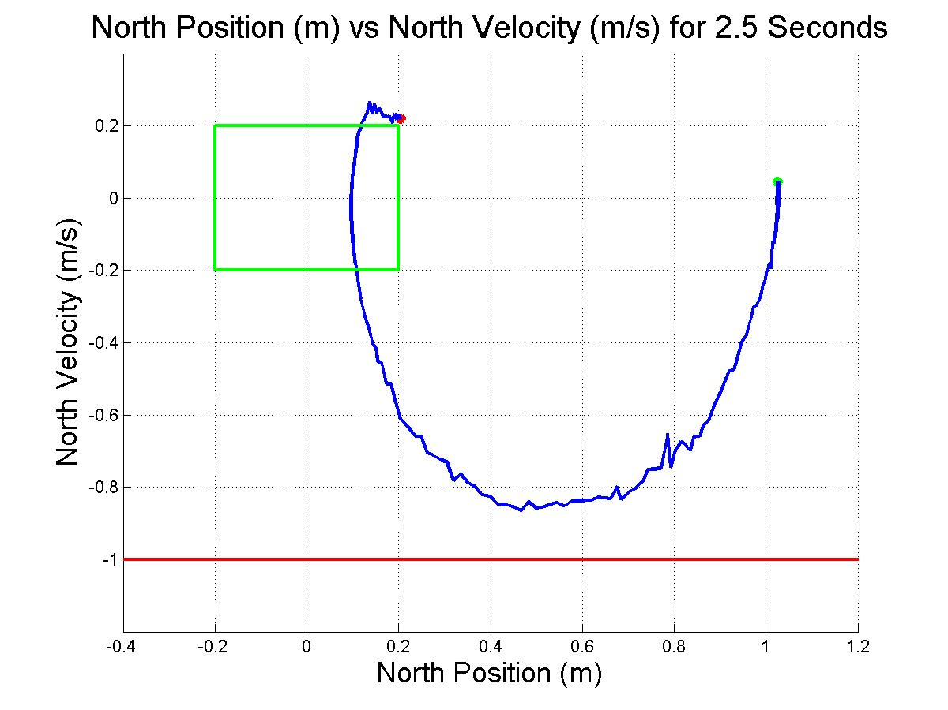

*Optimization of hybrid systems.* Switched dynamical systems have shown great utility in modeling a variety of systems. Unfortunately, the determination of a numerical solution for the optimal control of such systems has proven difficult, since it demands optimal mode scheduling. Recently, we constructed an optimization algorithm to calculate a numerical solution to the problem subject to a running and final cost. For such systems, the control parameter has both a discrete component, the sequence of modes, and two continuous components, the duration of each mode and the continuous input. We developed a bi-level hierarchical algorithm that divides the problem into two subproblems. At the lower level, we keep the modal sequence fixed and construct the optimal mode duration and optimal continuous input. At the higher level, we employ a single mode insertion technique to construct a new reduced cost sequence. We proved the convergence of this algorithm, and have illustrated its utility on several simulation examples, including flight planning for the STARMAC quadrotor. Recently, we modified our original approach in three ways to make our algorithm’s application more tenable. First, we transformed our algorithm to allow it to begin at an infeasible point and still converge to a lower cost feasible point. Second, we incorporated multiple waypoints into our cost function, which makes the development of an optimal control in the presence of multiple objectives viable. Finally, we extended our approach to penalize the number of hybrid jumps.

## Testing and Experimental Validation (Tomlin, Sastry, Lee, Karsai)

We continued testing the baseline controller design of the UAV platforms on the emerging model-based design tool suite. Experimental demonstrations are shown on our quadrotors above, and we continue to collaborate across MURI sites on the control development for the quadrotor platform.

# Personnel Supported

Berkeley:

1. Professor Claire Tomlin
2. Professor Edward A. Lee
3. Professor Shankar Sastry (funded elsewhere)
4. Jerry Ding (Graduate student, funded by this contract)
5. Humberto Gonzales (Graduate student, funded by this contract)
6. Maryam Kamgarpour (Graduate student, funded by this contract)
7. Man-kit (Jackie) Leung (Research staff, funded by this contract)
8. Eugene Li (Graduate student, funded by this contract)
9. Christopher Brooks (Software Engineer, funded 25%)
10. Haomiao Huang (Stanford graduate student, funded elsewhere)
11. Jeremy Gillula (Stanford graduate student, funded elsewhere)
12. Michael Vitus (Stanford graduate student, funded elsewhere)

# Publications

1. H. Gonzales, R. Vasudevan, M. Kamgarpour, S. S. Sastry, R. Bajcsy, and C. J. Tomlin, “A Numerical Method for the Optimal Control of Switched Systems”, Submitted to the IEEE CDC, 2010.
2. H. Gonzalez, R. Vasudevan, M. Kamgarpour, S. Sastry, R. Bajcsy, and C. Tomlin, Computable optimal control of switched systems with constraints, Proceedings of the 13th International Conference on Hybrid Systems: Computation and Control, 2010.
3. J. Gillula, G. Hoffmann, H. Huang, M. Vitus, and C. J. Tomlin. “Applications of Hybrid Reachability Analysis to Robotic Aerial Vehicles”, Submitted to IJRR, February 2010.
4. S. Shankaran, D. M. Stipanovic, and C. J. Tomlin, “Collision Avoidance Strategies for a Three Player Game”, Accepted to appear in the Annals of the International Society of Dynamic Games, 2010.
5. J. Gillula, H. Huang, M. Vitus, and C. J. Tomlin, “Design of Guaranteed Safe Maneuvers using Reachable Sets Autonomous Quadrotor Aerobatics in Theory and Practice”, In the Proceedings of the 2010 IEEE International Conference on Robotics and Automation, May 2010.
6. J. Ding and C. J. Tomlin, “Trajectory Optimization in Convex Underapproximations of Safe Regions”, In the Proceedings of the 48th IEEE Conference on Decision and Control, December 2009.
7. J. Gillula, H. Huang, M. Vitus, and C. J. Tomlin, “Design of Guaranteed Safe Maneuvers using Reachable Sets: Autonomous Quadrotor Aerobatics in Theory and Practice”, In the Proceedings of the 2010 IEEE International Conference on Robotics and Automation, May 2010.
8. J. Ding and C. J. Tomlin, “Trajectory Optimization in Convex Underapproximations of Safe Regions”, In the Proceedings of the 48th IEEE Conference on Decision and Control, December 2009.
9. J. Ding and C. J. Tomlin, “Safety and reachability in switched nonlinear systems under sampling and quantization”, Submitted to the IEEE CDC, 2010.
10. M. Kamgarpour and C. J. Tomlin, “Optimal Control of Non-Autonomous Switched Systems Under a Fixed Switching Sequence'”, Submitted to the SIAM Journal on Control and Optimization, 2010.
11. J. Gillula, H. Huang, M. Vitus, and C. J. Tomlin, “Reachable Sets for Maneuver Scheduling and Design: Applications to Autonomous Quadrotor Aerobatics”, In the Proceedings of the International Symposium on Robotics Research, September 2009.
12. J. Ding and C. J. Tomlin, “Aircraft conflict detection: a dynamic programming approach”, In the Proceedings of the AIAA Guidance, Navigation, and Control Conference, August 2009.

## Meetings and Industrial Outreach

## In addition to the MURI review meetings, we have presented our research results at the following conferences: AIAA GNC 2009, IEEE CDC 2009, ISRR 2009, ICRA 2010, HSCC 2010.

We have also presented our results to Boeing, Lockheed Martin, and Renault.

## Honors and Awards

1. Claire Tomlin:
   1. Chancellor's Professorship of EECS, UC Berkeley (2007-2010)
   2. Tage Erlander Guest Professorship, Swedish Research Council, 2009.
2. Shankar Sastry:
   1. Appointed Dean of Engineering, UC Berkeley, July 2007